Name: Pawan Pilgulwar Roll No: 205

Batch: S5

**HTML:-**

<!DOCTYPE html>

<html lang="en">

<head>

<meta charset="UTF-8">

<meta name="viewport" content="width=device-width, initial-scale=1.0">

<title>Reverse Digits</title>

<style>

body {

font-family: Arial, sans-serif; background: #e6f3ff; display: flex;

flex-direction: column; align-items: center; justify-content: center; height: 100vh;

margin: 0;

}

.container { background: #fff; padding: 5rem 6rem; border-radius: 10px;

box-shadow: 0 2px 8px rgba(0,0,0,0.1); text-align: center;

}

input[type="text"] { padding: 0.5rem; width: 250px; font-size: 1rem;

border: 1px solid #ccc; border-radius: 5px; margin-bottom: 1rem;

}

button {

padding: 0.5rem 1.5rem; font-size: 1rem; background: #28a745; color: #fff;

border: none; border-radius: 5px; cursor: pointer;

margin-bottom: 1rem;

}

button:hover { background: #218838;

}

.result {

font-size: 1.2rem; color: #333; margin-top: 1rem;

}

</style>

</head>

<body>

<div class="container">

<h2>Reverse Digits</h2>

<input type="text" id="inputNumber" placeholder="Enter a number here">

<br>

<button onclick="reverseDigits()">Reverse Digits</button>

<div class="result" id="result"></div>

</div>

<script>

function reverse_a_number(n) { n = n + "";

return n.split("").reverse().join("");

}

function reverseDigits() {

const input = document.getElementById('inputNumber').value; const reversed = reverse_a_number(input);

document.getElementById('result').textContent = `Reversed: ${reversed}`;

}

</script>

</body>

</html>

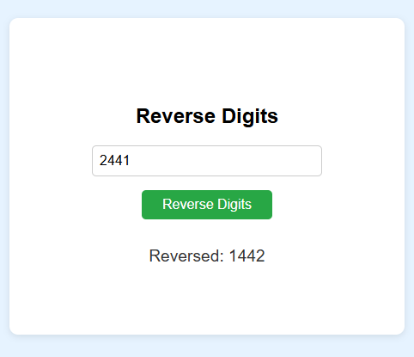OUTPUT:-